Business Requirements Document (BRD)
Project Name: Hall Booking System
Client: VDart
Version: P 0.1
Date: 13/08/2024

1. Document Details
Version & Date: D 0.1
Prepared by:Anubharathi P
Reviewed by:Alex
Approval Signature

2. Executive Summary / Introduction
- The client company, VDart, requires an internal Hall Booking System for its GCC Mannarpuram location.
- Currently, hall booking requests are managed semi-manually via emails sent to the admin team. This process leads to double-bookings, scheduling, and delays in confirmation.
- The proposed Hall Booking System will automate and streamline the process, enabling VDart teams to reserve halls for Business meetings, Project discussions, Fun activities, Forum sessions, and other events efficiently.

3. Business Objectives
Clearly state what the business wants to achieve.
Automate the Hall Booking Reduce the manual work.

4. Project Scope
- Hall Booking with the time Slot per booked based on peal-time calendar availability.
- After Booking the confirmation through mail to the user(Rejection,Alternate Hall).
- Admin dashboard for hall management.
- After utilization of the hall the user gets the thank you mail with the feedback form.
- If getting rejected the hall booking the admin will be giving it either available Halls based on their requirement

5. Stakeholder Analysis
Stakeholder |Role | Priority
SuperAdmin | All product Access| High
Admin |Manage the Hall Booking |High
User | Booking the hall |High
IT Support | Networking Infra Management | High

6. Current Process Overview
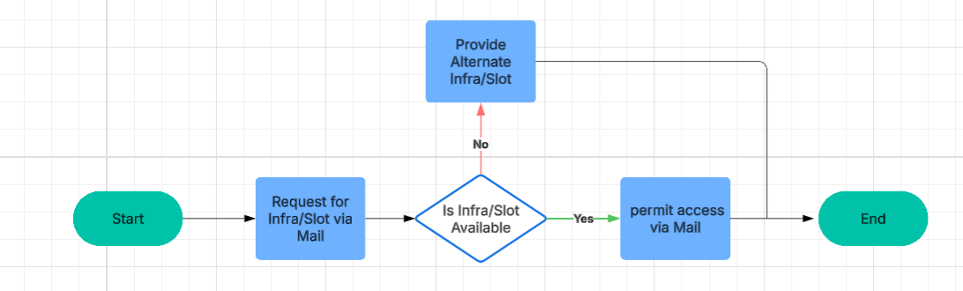

7. Proposed Solution Overview
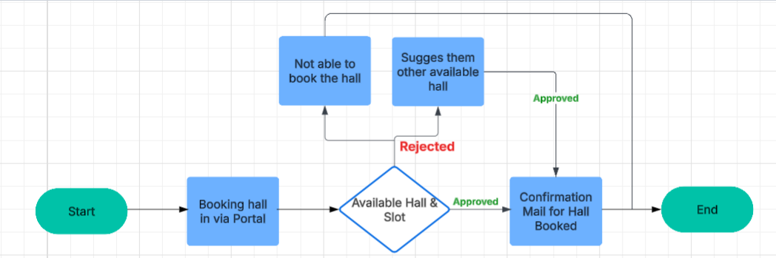

8. High-Level Requirements
- The system shall allow users to search for Office Location available halls.
- No need to login as a user.(Verified by the email OTP).
EmpId
EmpName
EmpEmail
- Once Verified the user then enters hall details and time slot .
- The system shall provide an input form for booking details:

  - Emp Mobile
  - Team Name
Admin
Ajay Sharma
ALDAR
Abirami Ramdoss
Arshad
Arun Franklin
Avishek Ganguly
Azharuddin
Balaji R
Bobby
BUH
Business Development
CFO
CHR
Corporate Finance
Corporate HR
Corporate HR - HRBP
Corporate HR - MY
Corporate HR - Ops
Corporate HR - TAG
Corporate HR - UAE
CSR
Customer Success
CX Team
David Sexton
Delivery and Excellence
Digital Practice - Mohr
Digital Transformation
Dilawar
Dimiour
Dimiour - Contract
Dimiour - Digital Practice
Dimiour - GE
Dimiour - HR Ops
Dimiour - Intern
Dimiour - TAG
Dimiour - TAG/Recruitment
Dimiour - Toy
Dimiour - VGO
Dimiour (Malaysia)
Dinakaran G
Dino Zeoff
Don Blessing Nelson S
Financial Planning and Analytics
GE - Contract Toyota -
GE Toyota -
Global Finance
Guna Sekaran. S
HR
IBEX
Ibrahim
Information Security
Innovation Hub
Innovation Hub - Intern
Internal IT
Jack Sherman
Seliyan
John David G
Karthik M
Kimberly Clark
Lance Taylor
Lingaprasanth
LnD
Manoj BG
Market Operations
Marketing
Max Taylor
Mgmt
Michael Romeo
Mohamed Irfan Peeran
Mohanavelu K A
Mohr Partner - IT
Mubashir
Murugesan S
Narasimman S
Narayan G
Naveen Senthilkumar
Oliver Sam
Omar Mohamed
Pal Nila
Prasanna J
Prassanna Kumar
Praveen
Premkumar
Priya
Projects
Projects - Contract
Rahul Ashok Kumar Mishra
Sastha Karthick Murugan
Rajkeran A
Recr-VDSS DS
Recr-VDSS DS - Contract
Revathi B
RevMedia
Rima Ghosh
Rohit
Saral
Shenbagapriya S
Siddahmed
Sini Mary X
Solomon Sebastian
Strategic Transformation
Supply Relationship Management
Suriya Senthilnathan
Toyota
Toyota - Administration
Toyota - Cloud DevOps - HXF
Toyota - Elixir
Toyota - IDP
Toyota - IDP - Contract
Toyota - IIM
Toyota - Mobile App
Toyota - Onboarding
Toyota - QA
Toyota - (not Vdart payroll)
Unique
Unique IT
Vandhana Ramakrishnan
Vdart Academy
VDart Gulf FZE
VDart Malaysia SDN BHD
VDSS DS
VDSS DS-HCL TnD
Verifone
Vijay
Vinay
Vouch
RFP
Guru Samy Nagarajan
Martin Raj Arockiasamy
Umera Ismail Khan
Recruitment DS
Internal Marketing
Business Lead Generation
Syed Ahmed (Sidd)
IKAROS
Celestine Soosai Manickam
Maheshwari Marimuthu
Melina
Johnathan
Felix
Faisal Ahamed
Others

  - It support(Toggle)
  - Description
  - Shift
Day
Mid
Night

  - Time Slot

- The system shall send booking confirmations via email to the user.
- The Admin can give the available other halls.
- The admin dashboard to manage halls.

10. Constraints

Budget Category | Amount | Percentage of Total
Personnel Cost | ₹1,40,000 | 25.93%
Equipment & Tools | ₹2,00,000 | 37.04%
Travel & Logistics | ₹1,00,000 | 18.52%
Training | ₹50,000 | 9.26%
Operational Cost | ₹40,000 | 7.41%
Contingency | ₹10,000 | 1.85%
Total | ₹5,40,000 | 100%
- Must be completed within 1 month.
- The system should be mobile-friendly.

12. Approval
Name | Role | Signature | Date
Alex | Project Reviewer

